SCHOOL OF COMPUTER SCIENCE AND ARTIFICIAL INTELLIGENCE |  |  |  |  | DEPARTMENT OF COMPUTER SCIENCE ENGINEERING
ProgramName:M. Tech |  |  |  | AssignmentType: Lab |  |  | AcademicYear:2025-2026
CourseCoordinatorName |  |  |  | Venkataramana Veeramsetty
CourseCode |  |  |  | CourseTitle |  | AI Assisted Problem Solving Using Python
Year/Sem |  |  | II/I | Regulation |  | R24
DateandDay  of Assignment |  |  | Week5 - Monday | Time(s)
Duration |  |  | 2 Hours | Applicableto  Batches
AssignmentNumber:10.1(Presentassignmentnumber)/24(Totalnumberofassignments)
 | Q.No. | Question |  |  |  |  |  | ExpectedTime  to complete
 | 1 | Lab 10 – Code Review and Quality: Using AI to Improve Code Quality and Readability  Lab Objectives  - Use AI for automated code review and quality enhancement.  - Identify and fix syntax, logical, performance, and security issues in Python code.  - Improve readability and maintainability through structured refactoring and comments.  - Apply prompt engineering for targeted improvements.  - Evaluate AI-generated suggestions against PEP 8 standards and software engineering best practices  Task Description #1 – Refactor Nested Conditionals  Task: Provide AI with the following nested conditional code and ask it to simplify and refactor for readability.  Python script.  def discount(price, category):  if category == "student":  if price > 1000:  return price * 0.9  else:  return price * 0.95  else:  if price > 2000:  return price * 0.85  else:  return price  Expected Output:  - Refactored code using cleaner logic, possibly a dictionary or separate helper functions.  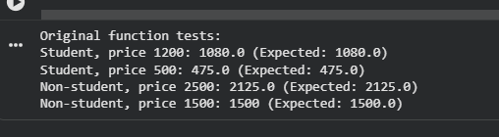  Code:  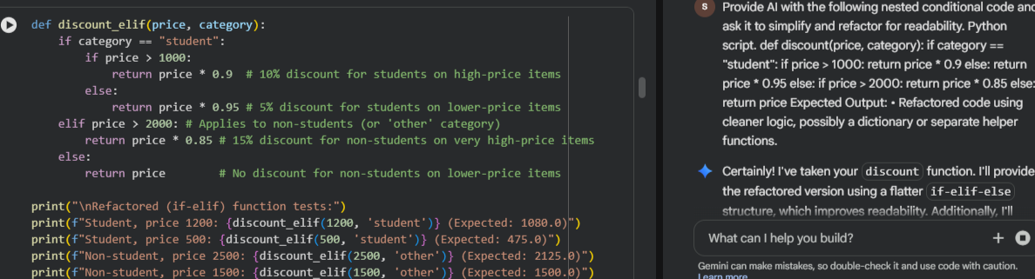  Output:  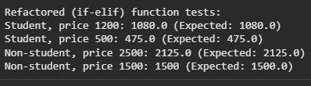  Task Description #2 – Optimize Redundant Loops  Task: Give AI this messy loop and ask it to refactor and optimize.  Python script  def find_common(a, b):  res = []  for i in a:  for j in b:  if i == j:  res.append(i)  return res  Expected Output:  Cleaner version using Python sets (set(a) & set(b))  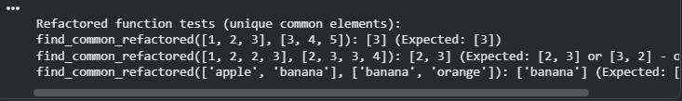  Code:  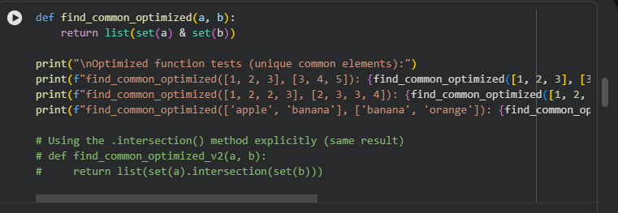  Output:  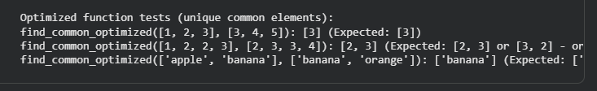  Task Description #3 – Improve Class Design  Task: Provide this class with poor readability and ask AI to improve:  - Naming conventions  - Encapsulation  - Readability & maintainability  Python Script  class emp:  def __init__(self,n,s):  self.n=n  self.s=s  def inc(self,p):  self.s=self.s+(self.s*p/100)  def pr(self):  print("emp:",self.n,"salary:",self.s)  Expected Output:  - Employee class with meaningful methods (increase_salary, display_info), formatted output, and added docstrings.  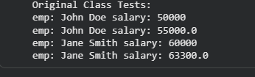  Code:  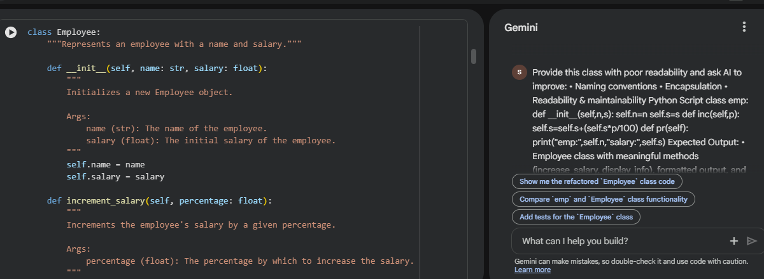  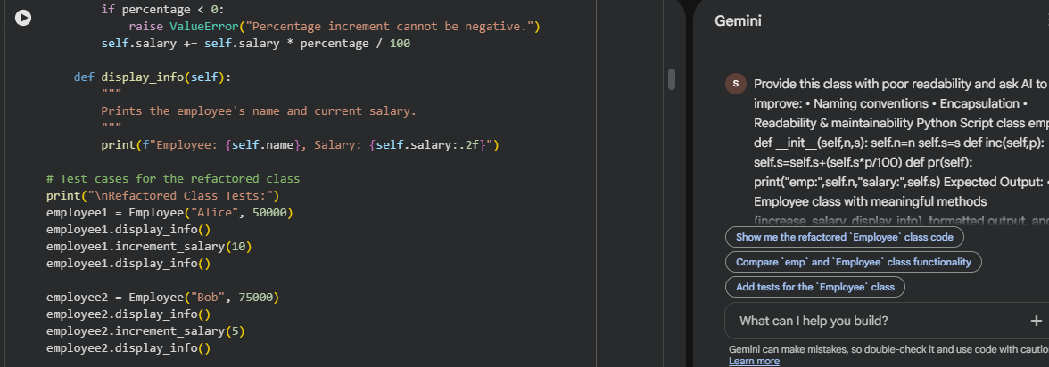  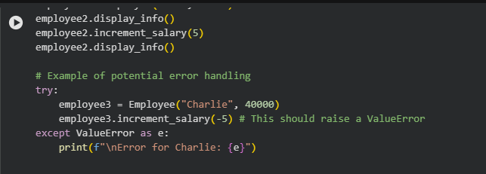  Output:  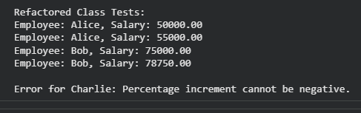  Task Description #4 – Modularize Long Function  Task: Give AI this long unstructured function and let it modularize into smaller helper functions.  Python Script  def process_scores(scores):  total = 0  for s in scores:  total += s  avg = total / len(scores)  highest = scores[0]  for s in scores:  if s > highest:  highest = s  lowest = scores[0]  for s in scores:  if s < lowest:  lowest = s  print("Average:", avg)  print("Highest:", highest)  print("Lowest:", lowest)  Expected Output:  - Split into functions: calculate_average, find_highest, find_lowest.  - Clean main process_scores() using helper functions.  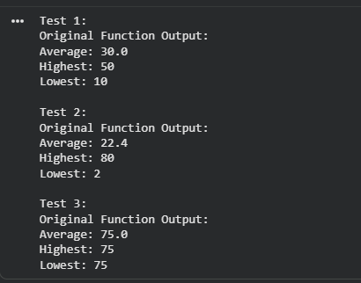  Code:  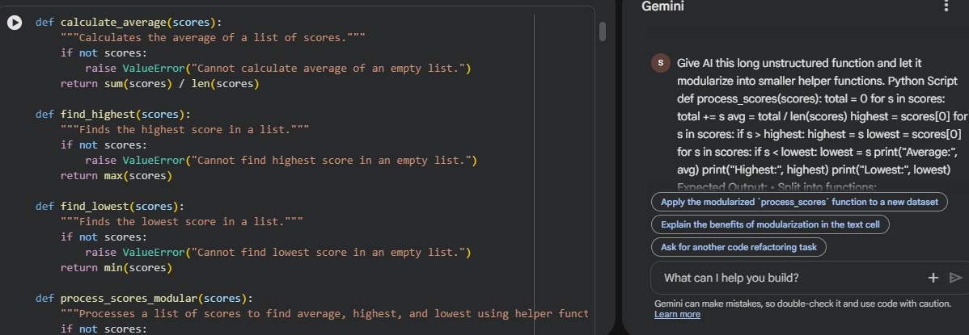  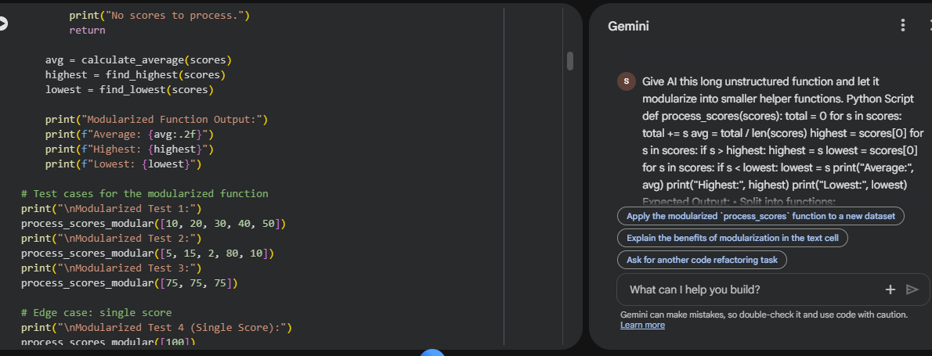  Output:  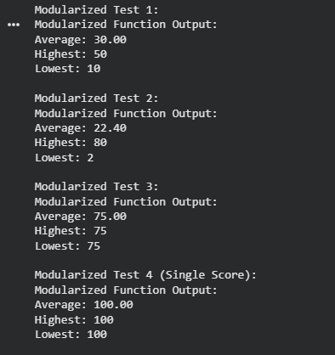  Task Description #5 – Code Review on Error Handling  Task: Provide AI with this faulty code and ask it to improve error handling, naming, and readability.  Python Script  def div(a,b):  return a/b  print(div(10,0))  Expected Output:  - Function with proper error handling using try-except.  - Better naming (divide_numbers).  - AI-generated docstring explaining error handling.    Code:  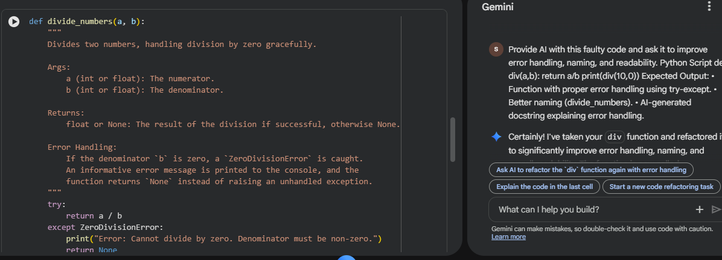  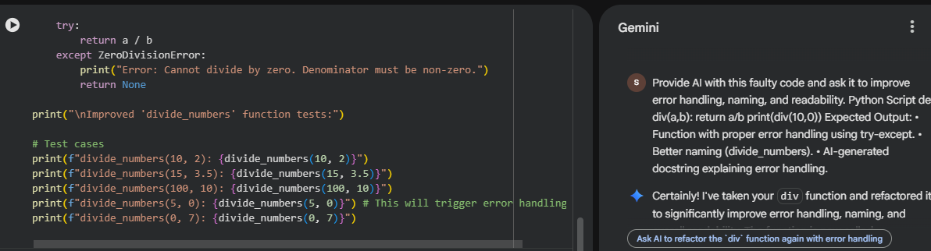  Output: 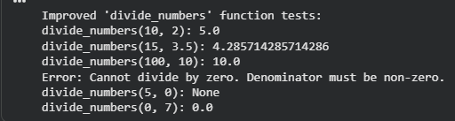  Task Description #6 – Complexity Reduction  Task: Use AI to simplify overly complex logic.  Sample Input Code:  def grade(score):  if score >= 90:  return "A"  else:  if score >= 80:  return "B"  else:  if score >= 70:  return "C"  else:  if score >= 60:  return "D"  else:  return "F"  Expected Output:  - Cleaner logic using elif or dictionary mapping.  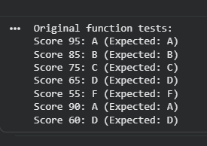  Code:  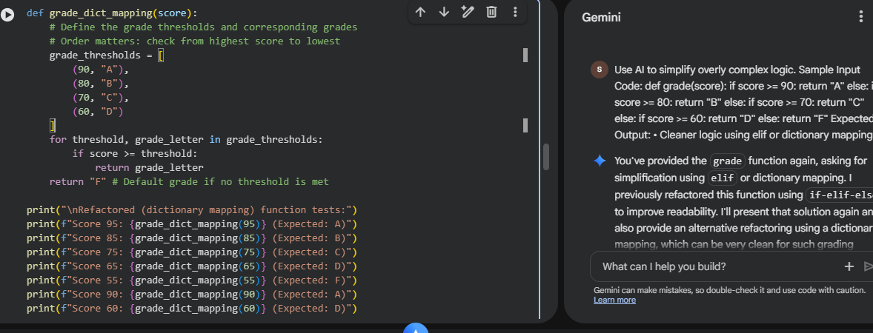  Output:  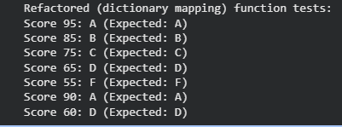 |  |  |  |  |  | Week5 - Monday

